**TSQL Homework 03**

**Question 1**

In general, why would you even want to join two (or more) tables together? This is a good time to think about the nature of relational algebra.

**Answer**

When you’re querying it would be easier to get all the info you need in one go.

**Question 2**

Describe in your own words the output from an inner join.

**Answer**

Inner Join clause in SQL server creates a new table (not physical) by combining rows that have matching values in two or more tables. This join is based on a logical relationship (or a common field) between the tables and is used to retrieve data that appears in both tables. It deletes all rows that return FALSE from a row filter

**Question 3**

Describe in your own words the output from an outer join.

**Answer**

When performing an inner join, rows from either table that are unmatched in the other table are not returned. In an outer join, unmatched rows in one or both tables can be returned. There are a few types of outer joins: LEFT JOIN returns only unmatched rows from the left table.

**Question 4**

Describe in your own words the output from a cross join.

**Answer**

The CROSS JOIN is used to generate a paired combination of each row of the first table with each row of the second table. This join type is also known as cartesian join. The main idea of the CROSS JOIN is that it returns the Cartesian product of the joined tables.

**Question 5**

A convenient mnemonic for remembering the various joins is “Ohio.” Why is this true?

**Answer**

What has two round sides and is high in the middle. Left outer join, right outer join, full join

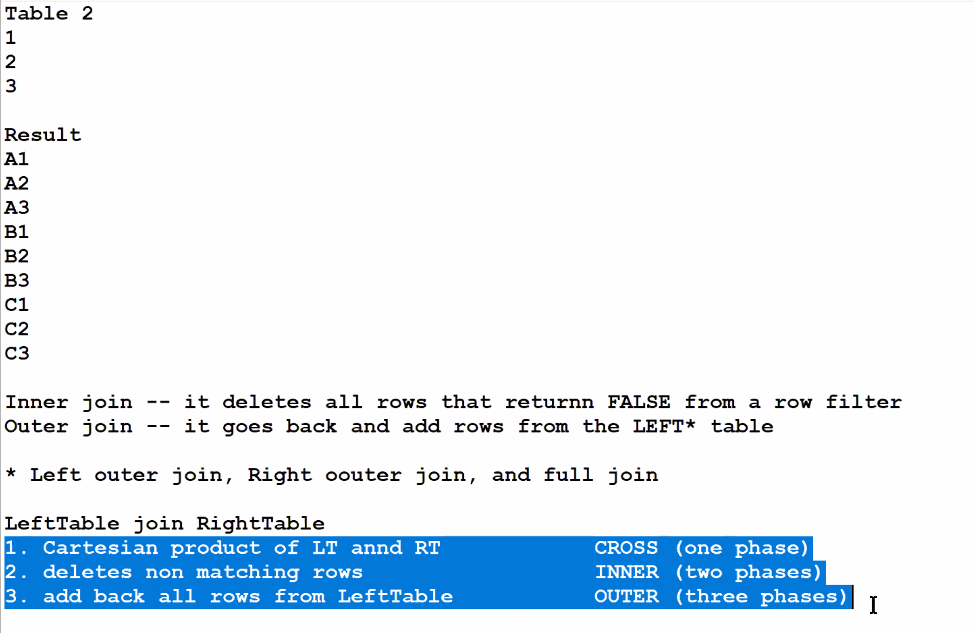

**Question 6**

Give an example of a composite join.

**Answer**

SQL join with composite primary key. SQL join composite composite-primary-key. I have to join two table. But in one table primary key is not there, composite primary key is there, means three columns put together uniquely define a row of that table.

**Question 7**

What is the difference between the following two queries? The business problem is “How many orders do we have from each customer?”

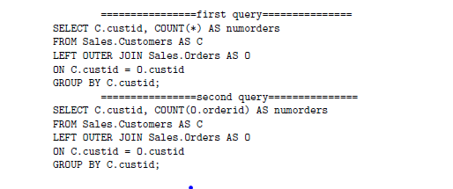

**Answer**

The bottom one counts all the orderid’s which would be all the orders, which is the correct way.

**Question 8**

What might be one reason the following query does not return the column *custID* in this query?

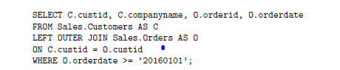

**Answer**